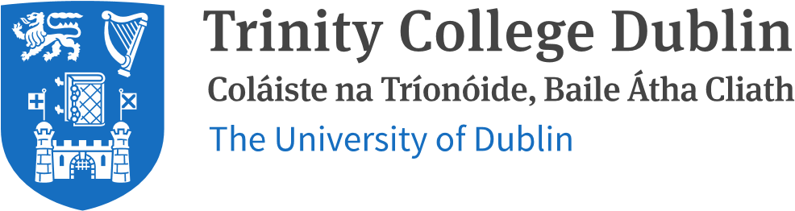

DECLARATION

I understand that this is an individual assessment and that collaboration is not permitted. I have not received any assistance with my work for this assessment. Where I have used the published work of others, I have indicated this with appropriate citation.

I have not and will not share any part of my work on this assessment, directly or indirectly, with any other student.

I have read and I understand the plagiarism provisions in the General Regulations of the University Calendar for the current year, found at [http://www.tcd.ie/calendar.](http://www.tcd.ie/calendar/)

I have also completed the Online Tutorial on avoiding plagiarism ‘Ready Steady Write’, located at [http://tcdie.libguides.com/plagiarism/ready-steady-write.](http://tcd-ie.libguides.com/plagiarism/ready-steady-write)"

I understand that by returning this declaration with my work, I am agreeing with the above statement. ✅

Name: MUDIT GARG

Date: 15TH DECEMBER, 2022